Yu Li Li
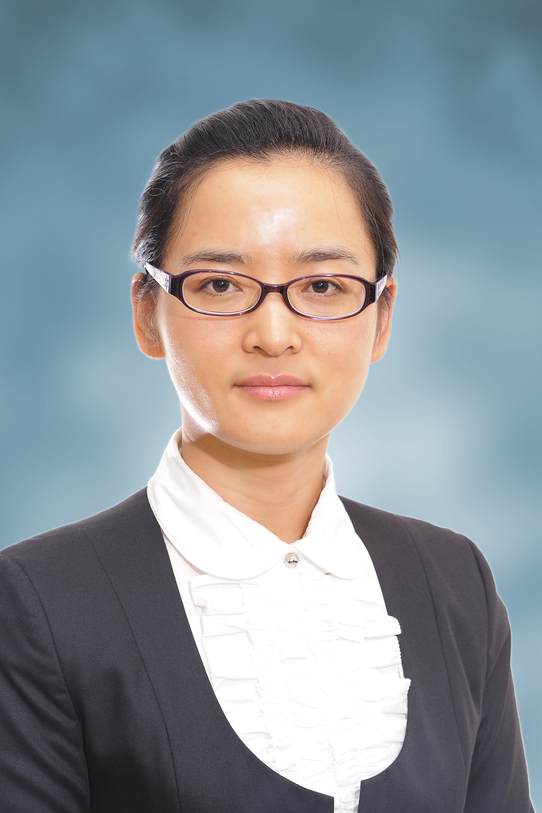 |  | Position : | Assistant Professor
 |  | Faculty : | Faculty of Chinese Medicine
 |  | Email Address : | llyu@must.edu.mo
 |  | Telephone : | (853) 8897-2497
 |  | Fax No. : | (853) 2882-5123
 |  | Office : | H618a
 |  | Mailing Address : | Avenida Wai Long, Taipa, Macau
Teaching and Research Areas :
Teaching subjects: Fundamentals in Chinese Medicine, Diagnostics of traditional Chinese Medicine, Science of Formulae of Chinese Herbs, Forums and Lectures of Internal Classic, Febrile Diseases, Advances in Research into Traditional Chinese Medicine, Current Topics in Basic Research of Chinese Medicine.
Research Areas: TCM syndrome differentiation, TCM body Constitution and Health Preservation.
Academic Qualifications
2008-2011 | Ph.D / Diagnostics of traditional Chinese Medicine / BeiJing University of Chinese Medicine
2005-2008 | Master / Diagnostics of traditional Chinese Medicine / BeiJing University of Chinese Medicine
1999-2004 | Bachelor / Traditional Chinese Medicine / HeiLongJiang University of Chinese Medicine

Teaching Experiences
2011 - Present | Teaching Staff / Faculty of Chinese Medicine / Macau University of Science and Technology

Representative Publications
Journal Articles: 14
Academic texts: 1
Conference Proceedings: 3

Research Grants/Projects
2017 - 2018 | Study on the Promotion and Application of Assessment Rubrics in Chinese Medicine Course(Science of Formulae of Chinese Herbs)（MF-17-005a-A）
2013 - 2017 | Study on the molecular mechanisms of protective effects of muscone on  myocardial ischemia-reperfusion injury in rats (FDCT)

Academic Membership and Services
2014-2022 | China Association of Chinese Medicine for Diagnostics of traditional Chinese Medicine

Professional Qualifications and Awards
2017 1st class of Service Award(ZhongZhu Medicine & Life Science Excellent Teacher Award Announcement 2016/2017.
2014 Rising Star (Teaching Excellence Award 2013/2014.
2011 The first prize of the Science and Technology Award (the China Association of Chinese Medicine.
2010 Outstanding Paper Award (the 8th annual academic conference for PH.D candidates.
2010 Outstanding Paper Award( the first Chinese Medicine doctor paper.
2009 Practicing physician of the People's Republic of China .

