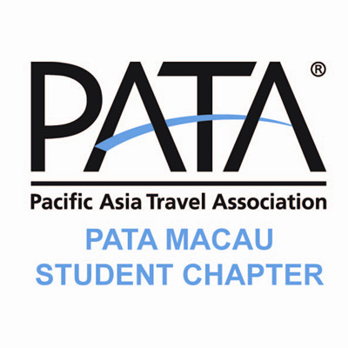

Dear all students of MUST,
Greeting from PATA Macau Student Chapter!
The PATA Macau Student Chapter has recently been established on 19 April 2012 in Malaysia. It is an association subordinated under PATA (Pacific Asia Travel Association) and the PATA Macau Chapter. Moreover, we are in cooperation with several major educational institutions in Macau providing professional knowledge and advices to all members in different aspects related to the tourism industry.
In addition, the PATA Macau Student Chapter organizes field to famous tourism destinations and renowned organizations under PATA where members can learn and widen their span of view from the real practice. Members are also given the opportunity to take part in PATA events to become more acknowledgeable about the structures, managements and tactics involved in this international association.
Right now, we are seeking students to take part in the Chapter’s Executive Committee as the executive members. To be an executive member of the Chapter, you will be responsible for the daily operations and the managements of PATA Macau Student Chapter which may include assistance in script writing, information researches, event arrangements and coordination etc. The information about the position included in executive committee and the job description have enclosed in this notice.
We highly focus on working initiative, efficiency and punctuality. If you think you are eligible for our position, we warmly welcome you to become part of our Executive Committee. For interested parties, please complete the application form enclosed in this notice, and send it to us through email by 6th, May, 2013.
Please reply us via your full name, university, desired position, and also your interview time slot s follow:
10th, May 2013 1930-2300
11th, May 2013 1400-2230
The email address is pata.stud@ift.edu.mo.

Also, if you are a PATA member, please also state your PATA ID number.
If you have any questions regarding to the recruitment, please feel free to reply back via this email or you could contact Gill Sun孫雪霏 (6216 9496) or Rain Cheng程詩雨 (6379 0808) directly.
Best regards,
Ariel Lin Ken Xu
Chairman Vice Chairman
PATA Macau Student Chapter

